ΣΤΙΒΟΣ

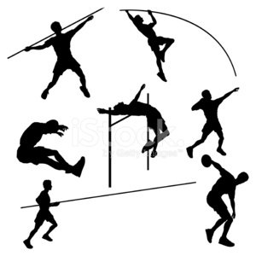

https://www.sutori.com/story/stibos--JY5QegDqVP48kjdSp4sD7SGd

