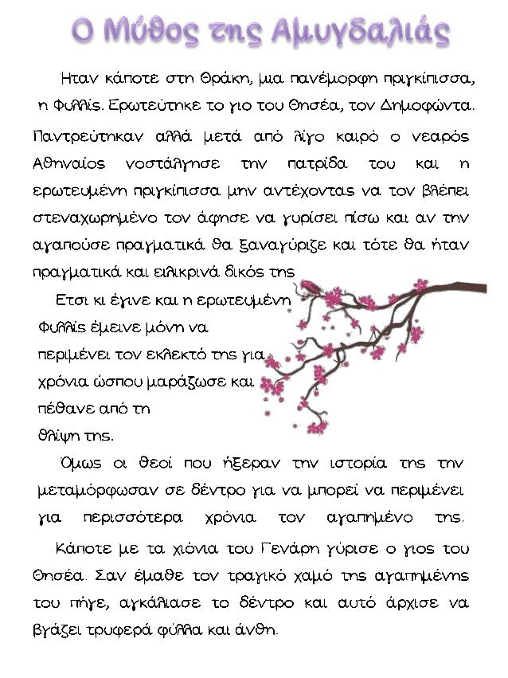
ΓΡΑΦΩ ΤΗΝ ΠΕΡΙΛΗΨΗ ΤΟΥ ΜΥΘΟΥ…
………………………………………………………………………………………………………………………………………………………………………………………………………………………………………………………………………………………………………………………………………………………………………………………………………………………………………………………………………………………………………………………………………………………………………………………………………………………………………………………………………………………………………………….

